Name :- Deval Prajapati

Enrollment no:- 2201030400109

Roll no :- B-90

Subject – WT

Assignment-1

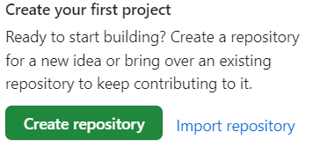

Create a repository with create button

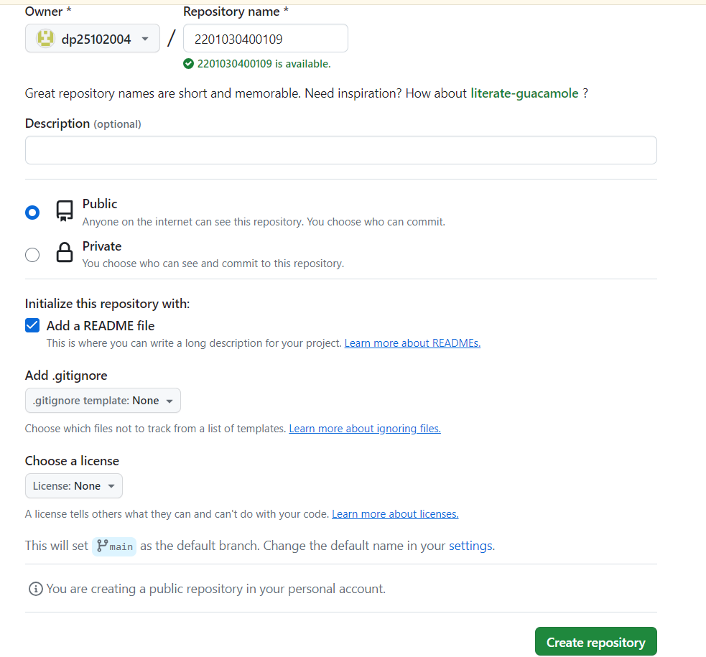

Create a name as a enrolment no as repository name.

